***Assignment Unix***

**tar (tape archive)**

This command is used to compress the directories and files

**Options**

-c :- create a new archive

-v:- verbosely show the .tar file progress

-f:- file name of the type archive.

-x:- extracting the files.

-r:- like -c but new entries are appended to archive. It only works on uncompressed archives stored in regular file. The -f option is required.

**Problems:**

1.Creating an uncompressed tar archive using option –cvf for the backup of files.

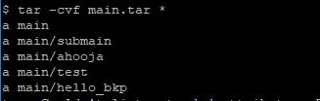

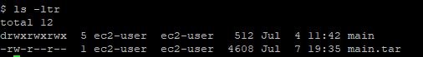

2. Extracting files from archive using option –xvf

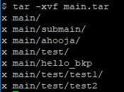

**Find**

This command can be used to find files and directories and perform subsequent operations on them. It supports searching by file, folder, name, creation date, modification date etc.

**Options:**

-name: **Search a file with specific name.**

**-**perm : **Search for file with entered permissions.**

**Problems:**

1. Find all files having permission mode 777.

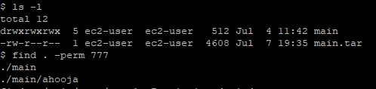

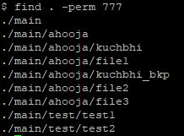

1. Search text within multiple files.

$ find ./ -type f -name "*.txt" -exec grep 'delhi' {} \;

This command print lines which have ‘delhi’ in them and ‘-type f’ specifies the input type is a file.

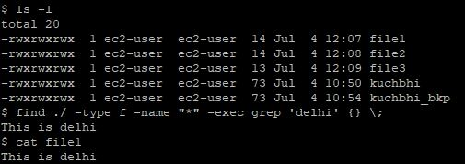

**locate**

The difference lies in the way of processing. Unlike find(searching file system), locate searches file with the help of a database for all pathnames which matches the specified pattern. It is comparatively faster than find.

**Options:**

-c : displaying number of matching entries.

-i : ignore case distinctions when matching patterns.

-S : for reviewing local database statistics.

-e : Print only entries that refer to files existing at the time locate is run.

**Problems:**

1. Displaying number of matching entries.

locate1

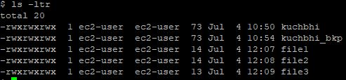

1. Review local database.

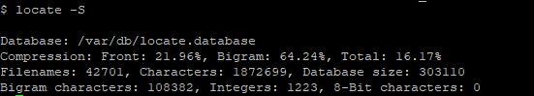

**diff**

It is a command which compares file line by line with an additional advantage.Symbols used for instructions are (a: add, c: change, d: delete)

**Options:**

**-c (context) :** To view differences in context mode.

-u(unified) : To view differences in unified mode.It does not show the redundant information.

**Problems:**

1. To find difference between 2 files.

1c1 means change line 1 in file 1 to match file2.

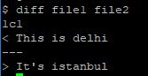

1. To view differences of two files in context mode.

! tells that these files don’t have same content.

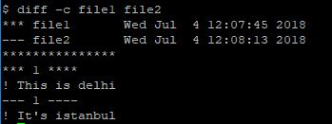

**Tail**

It is a utility command to see the last lines added to files through standard input.

**Options:**

-n: Lines

-c : bytes

-f:for continuously viewing the last ten lines of a file and will update when new lines are added. As new lines are written to the log, the console will update with the new lines. The prompt doesn’t return even after work is over so, we have to use the interrupt key to abort this command. In general, the applications writes error messages to log files. You can use the **-f** option to check for the error messages as and when they appear in the log file.

**Problems:**

1. Prints last ‘num’ lines from specified file instead of 10 lines.

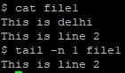

1. Prints last ‘num’ bytes from specified file.

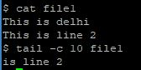

**less**

less command is generally used with large files to view the contents of file page by page. it is fast because it loads the content page wise rather than complete file at a time.

**Options:**

-E : causes less to automatically exit the first time it reaches end of file.

-i : cause searches to ignore case.

-f : forces non-regular file to open.

**Problems:**

1. To find pattern in a file,by using / to search the pattern.

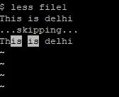

1. To display file with real time appends.

less2

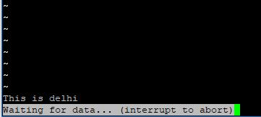

**ln**

1. This command is used to create links between files.
2. Links help many files to refer to or point to a single file in case of hard link and soft link respectively.

**Options:**

**-s : soft link**

**-b : existing link**

**Problems:**

1. Create hard link between two files.

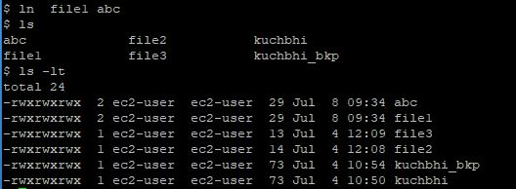

1. Create soft link between two file

